# DOSE SMART-MINI PROJECT

# ABSTRACT

Our project idea is to design a web based platform to provide a convenient and user-friendly way for the users to browse, search, and purchase medicines online. The users can search for medicines, view medicine details and add medicines to their shopping carts. They can also have consultation with specialists. One of our project's features is to provide the information about various diseases when the symptoms are provided. Thus, our project aims to provide convenience and service to the people.

Dose Smart presents an innovative approach to medication management through its intelligent dosing system. This technology combines smart devices with a user-friendly interface to optimize medication adherence and dosage precision. Dose Smart employs personalized reminders, real-time tracking, and data analytics to empower users in managing their medication schedules effectively. With connectivity to healthcare providers, it facilitates remote monitoring, ensuring timely intervention and improved patient outcomes. This abstract highlights the potential of Dose Smart to revolutionize medication adherence, leveraging cutting-edge technology for a more intelligent and patient-centric approach to healthcare.

# INTRODUCTION

# Hospital management systems during the COVID-19 pandemic became indispensable tools, streamlining operations, enhancing patient care, and ensuring efficient resource allocation. These systems facilitated remote consultations, patient triaging, real-time data analysis, and effective staff coordination, playing a crucial role in adapting healthcare services to the evolving pandemic landscape. From patient tracking to inventory management and scheduling, these systems were essential in maintaining hospital efficiency and optimizing healthcare delivery despite the challenges.

# Dose Smart represents a groundbreaking advancement in the realm of medication management, offering a sophisticated solution to address the challenges of medication adherence and dosage precision. In an era where healthcare is increasingly influenced by technology, Dose Smart emerges as a beacon of innovation, seamlessly integrating smart devices and intuitive interfaces to empower individuals in taking control of their medication routines.

# As the prevalence of chronic conditions rises, the importance of precise medication adherence cannot be overstated. Dose Smart recognizes this imperative and steps forward with a comprehensive system designed not only to remind users of their dosages but to intelligently adapt to individual needs. This introduction delves into the transformative capabilities of Dose Smart, shedding light on its potential to redefine how we approach medication management, ultimately fostering improved health outcomes and patient well-being.

# TECHNOLOGY

## SOFTWARE REQUIREMENTS SPECIFICATION :

>WEB DEVELOPMENT

FRONT END:

* + HTML
  + CSS

# 

# PROPOSED WORK

# DESIGN

# C:\Users\lenovo\Desktop\FC.PNG

**RESULTS**

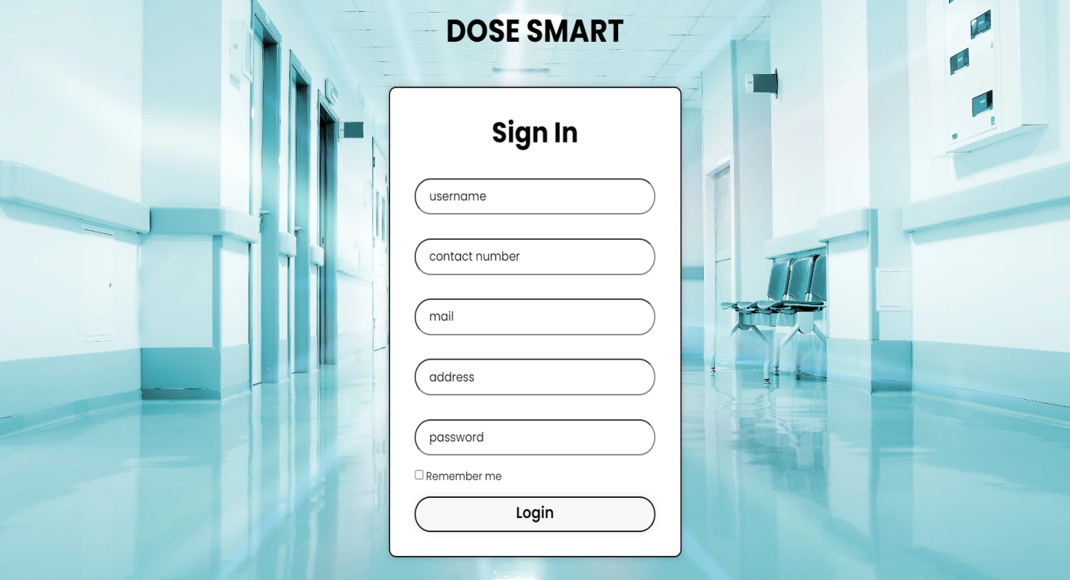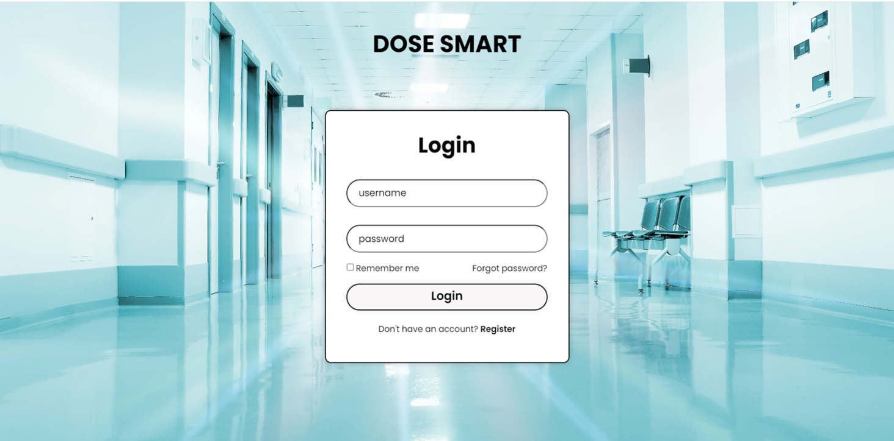

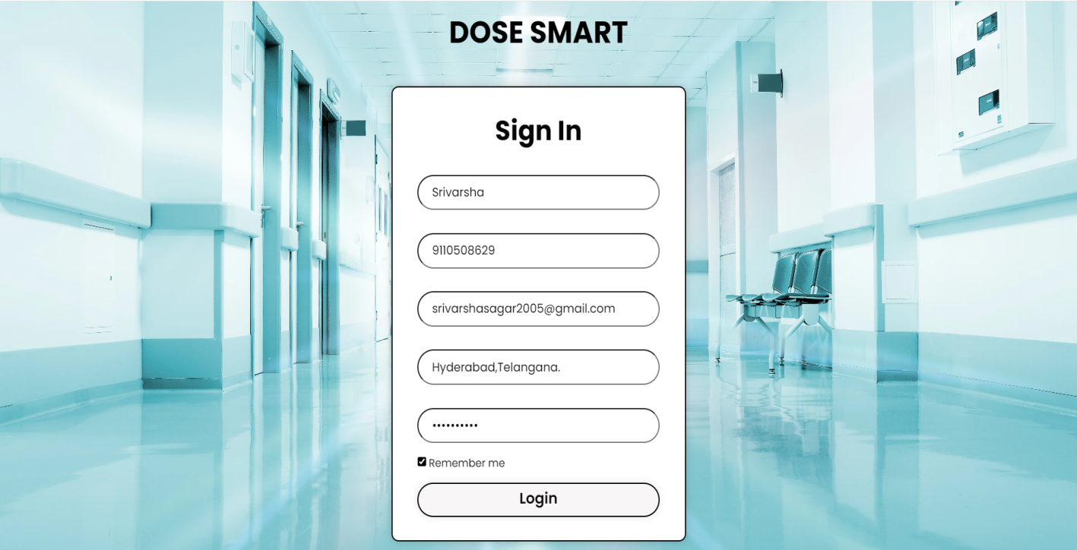

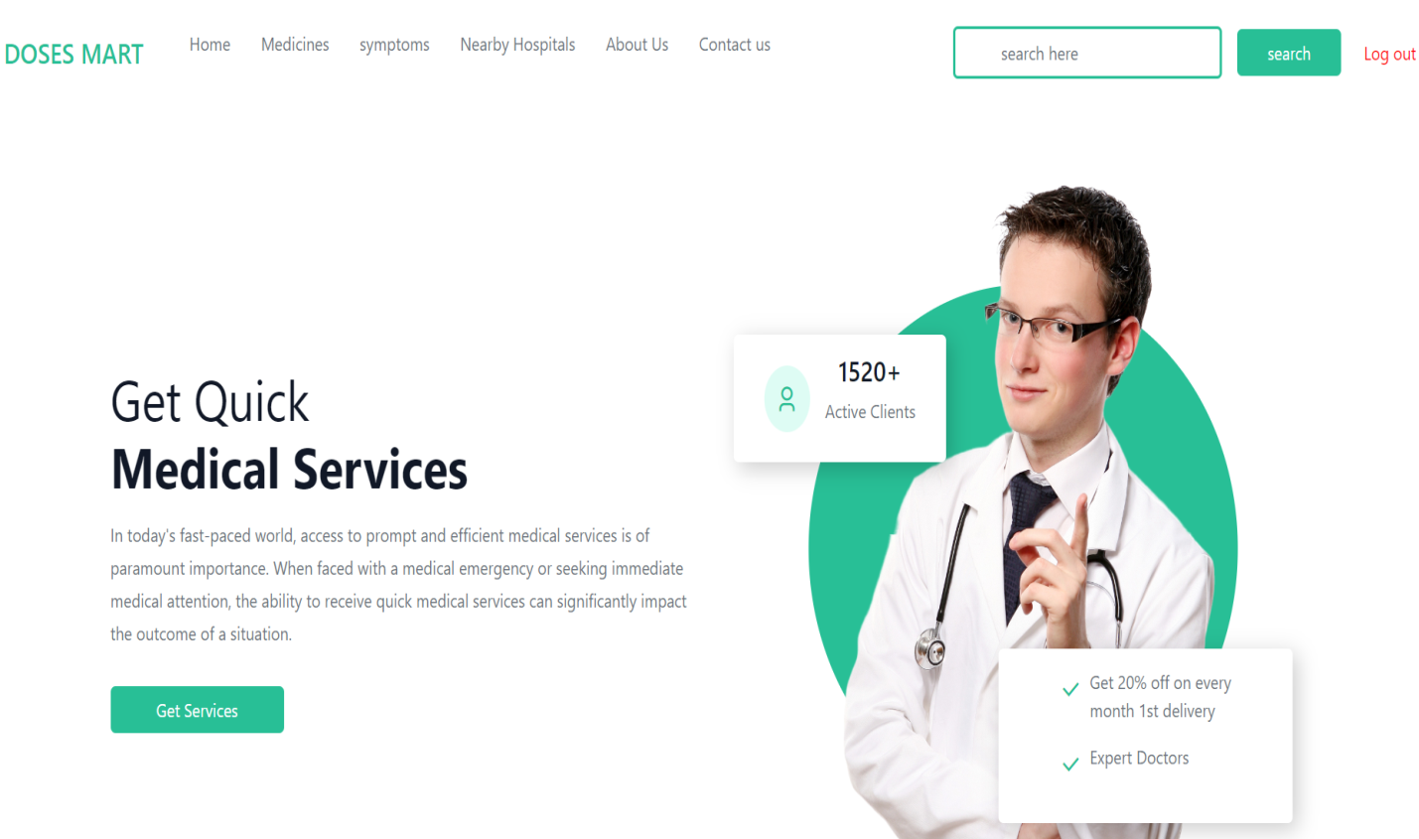

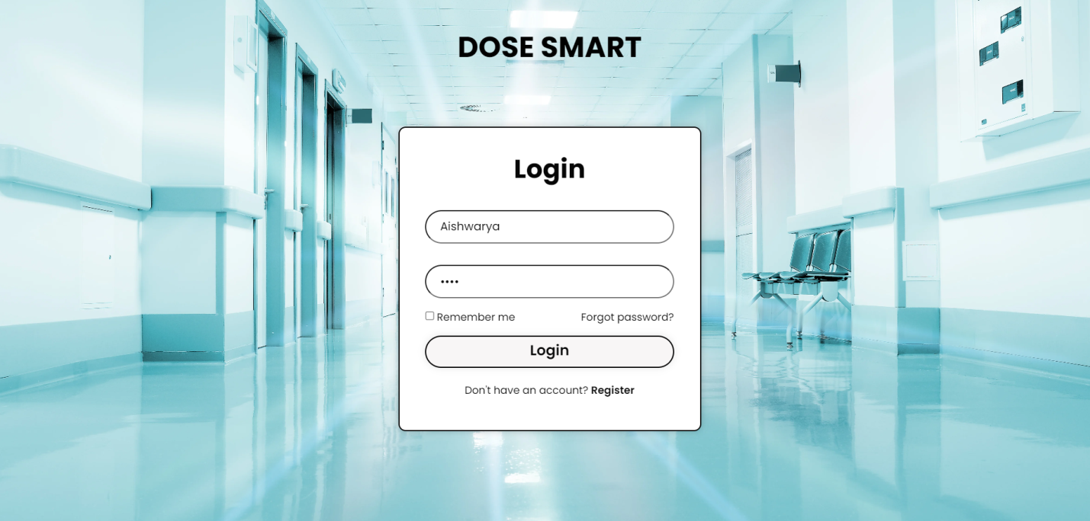

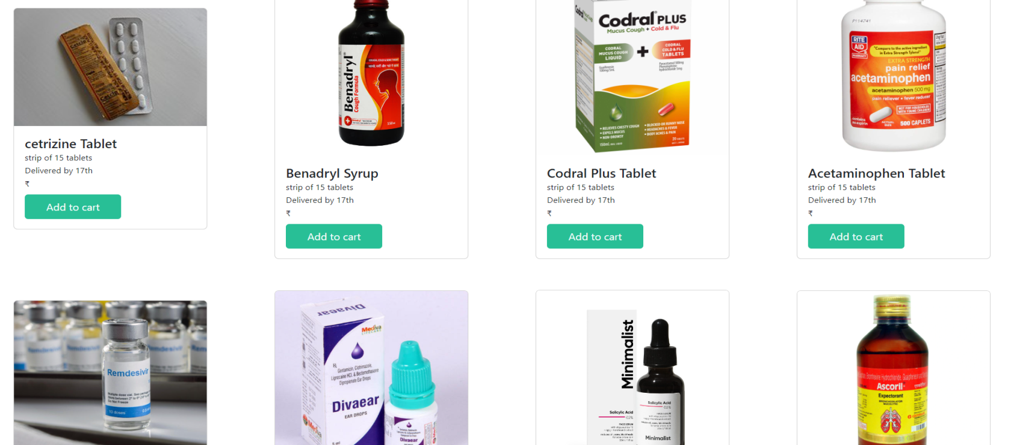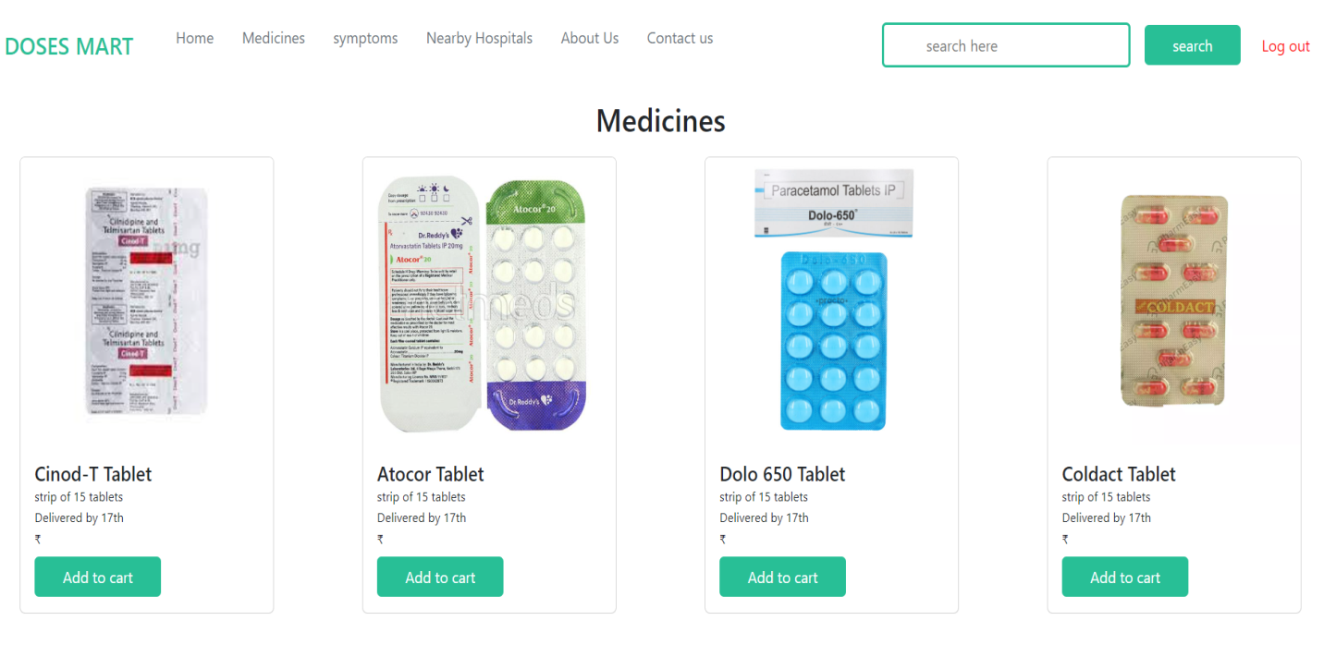

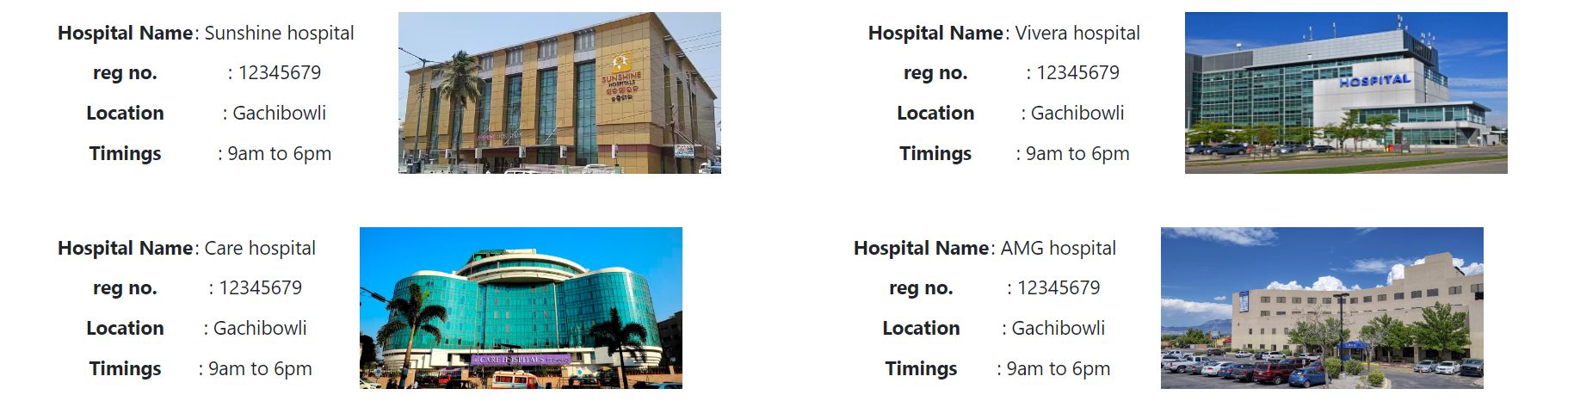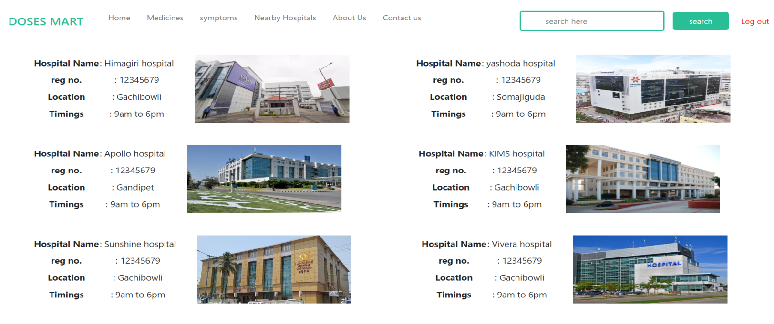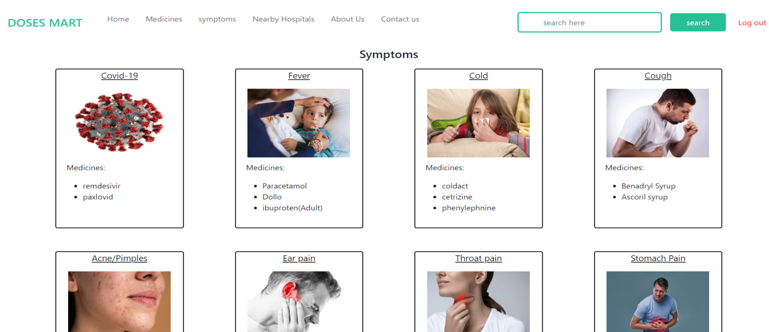

# 

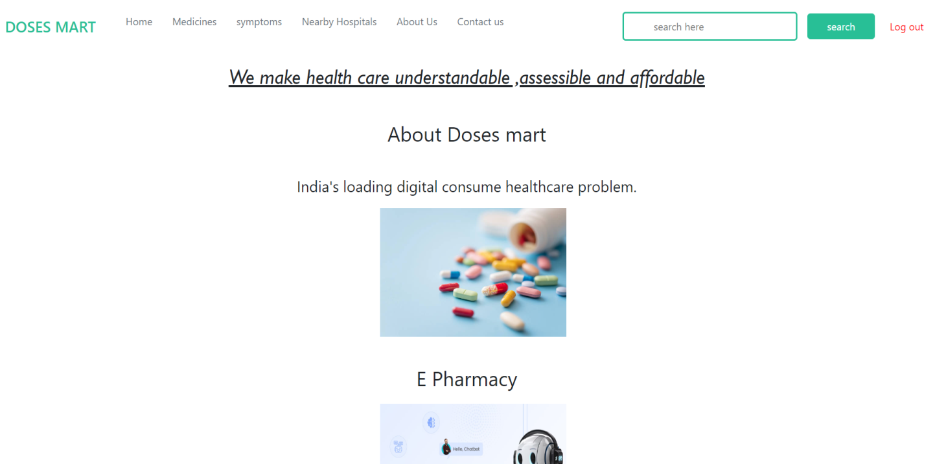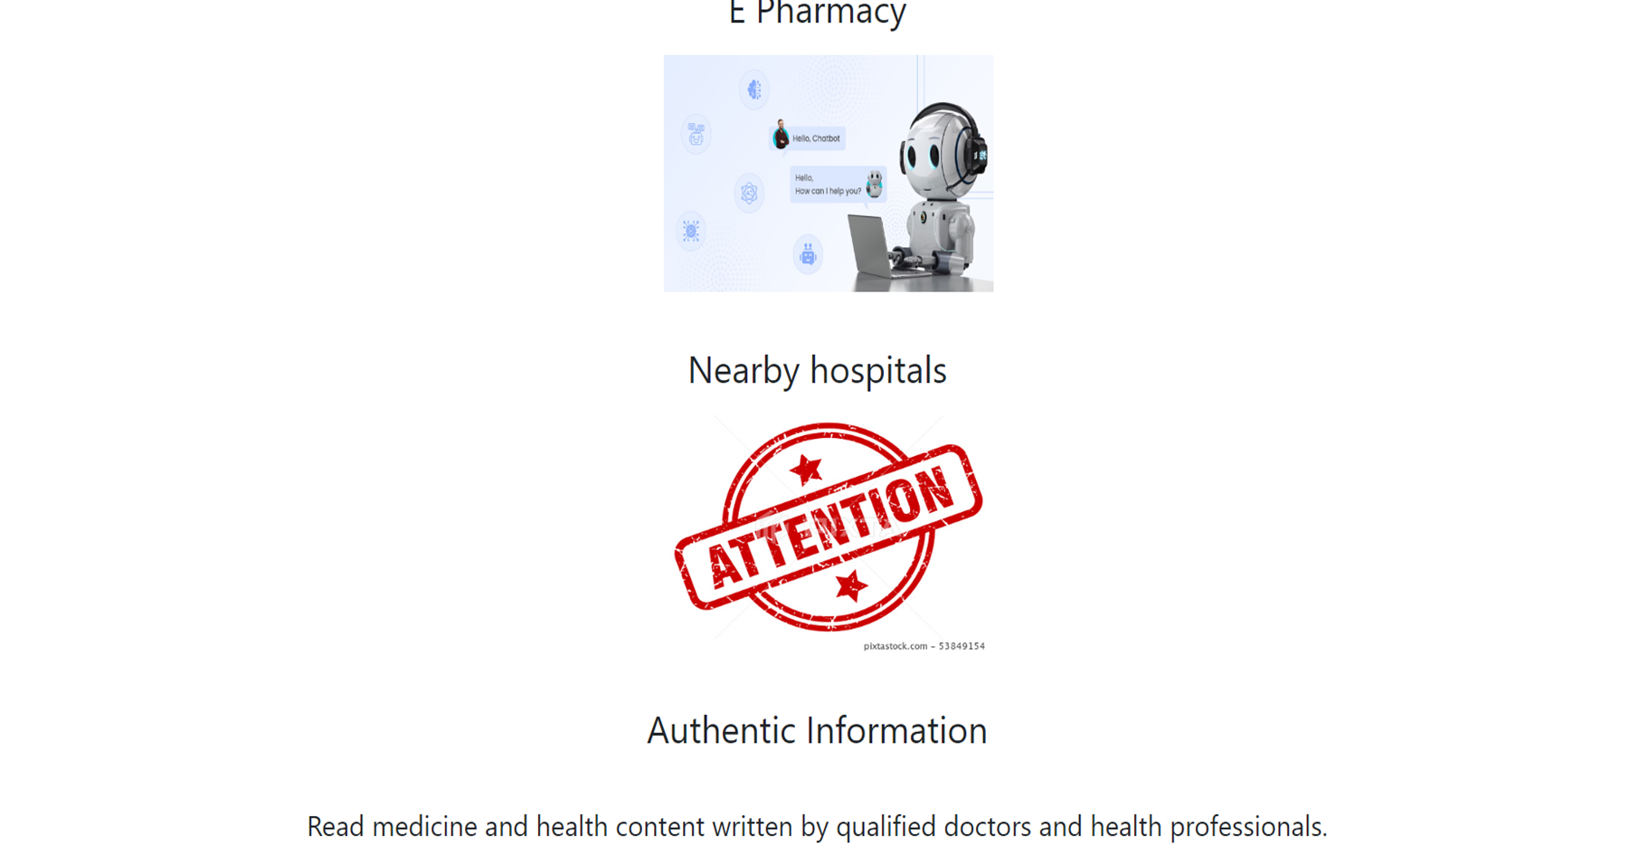

# ADDITIONAL KNOWLEDGE GAINED BY THIS PROJECT

As we are implementing our project we came to know the front end technology, new Computer languages and different ways to approach for a project processing to the submission .We also have made many discussions within teams and also with the elders, by this we came to know how a teamwork happens in an organisation.

# CONCLUSION & FUTURE WORK

# In concluding the medicine website project, it's crucial to emphasize its role in providing a user-friendly platform for accessing essential medical information, fostering awareness, and promoting health literacy. The project aimed to bridge the gap between patients and credible healthcare resources, ensuring accessibility to reliable information in an easily navigable format. Moving forward, continual updates, user feedback integration, and adherence to evolving medical standards will further enhance the website's effectiveness, making it a valuable resource in empowering individuals to make informed healthcare decisions

# REFERENCE WORK

* INTERNET
* WEB BROWSING
* YOUTUBE
* UDEMY COURSE